Robert Weischedel

CS 5780

3/8/17

Lab 6 – Post Lab

Image from Generating Waveforms with the DAC part of in-lab exercises

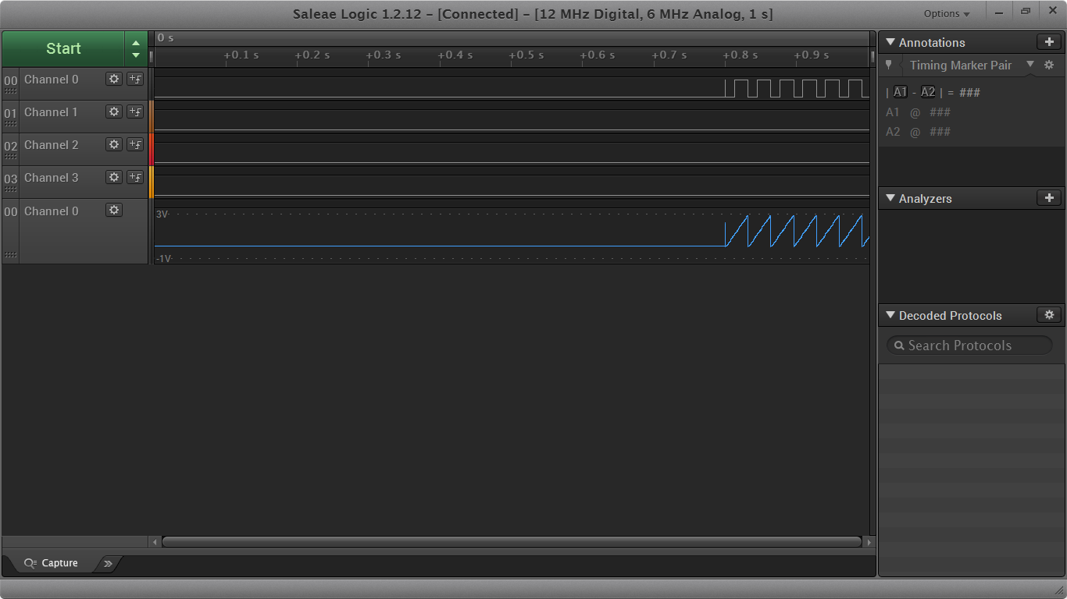

1. Some of the GPIO pins have multiple analog functions. Since the analog bus isn't configurable these pins connect to all of their analog functions at the same time. Why doesn't this cause problems?
   * Hint: Take a close look at what the analog functions are, you may need to look stuff up.

This is because the designers never put multiple outputs on the same pin. But it is okay when there are multiple inputs and also a mix of inputs and outputs. By doing so the designers prevent inputs/outputs from begin converted into formats that are incorrect.

1. Consider a system where the DAC is updated every 4us (250 kHz) with a value from a 200-element wave table containing a single cycle of a waveform. What would be the frequency of the output wave?

250 kHz / 200 samples per cycle = 1250 Hz frequency output wave.

1. Consider that the ADC in 12-bit mode divides the input voltage range (0-3V) into 4096 steps. (where 0V is 0, and 3V is 4095)
   * What is the voltage/measurement resolution of the ADC? (what change in voltage does 1 bit in the output equal)
   * What value would the ADC output if the input voltage was 1.75V? (round output to nearest integer)

For each change of voltage, the 1 bit in the output equals about 342. Because 4095/12 = 341.25.

The value for the ADC output if the input voltage was 1.75V would be 2,389.